Preview of schedule before normalization:

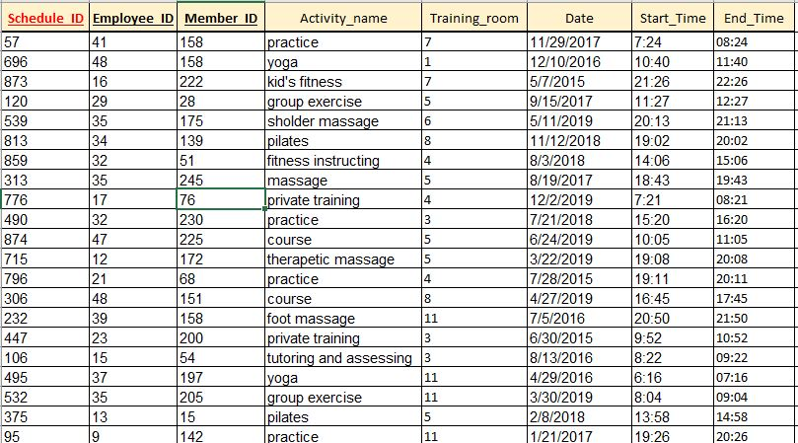

Entity is in 3NF.

PK is schedule_ID.

FK’s are employee_ID and member_ID.